hello


**[P] Team 3: The Development of Ctrl+S(tudy)**

We are team Ctrl + S(tudy) from Protons IEEE. The name is inspired by the short cut (Ctrl + S) which saves progress as we want the student to see progress when completing his task and saving his time and efforts.

This Technical Report Will Discuss:

1. the idea of our website
2. How did we divide the work?
3. Discussion about our code
4. What Different Errors We Faced and How we handled it

Our website Repo

👇



Team Members:

* Ziad said abdelaal
* Anas Mostafa Hussein
* Remas Mostafa Hussein
* Joudy Mohamed Sabry
* Hanna Islam Ahmed
* Kareem Hassan Mohamedeen

_______________________________________

**First**, we divided the website into 5 Webpages:

[Login - Tasks - Pomodoro - Chatbot - Contact us]

Note: Every Section may Contain more than 1 page

Note: Total Pages of our website is 7 Pages

Every Section Contain 1 Page Except Login Section:

[Login - Register - Forget Password]

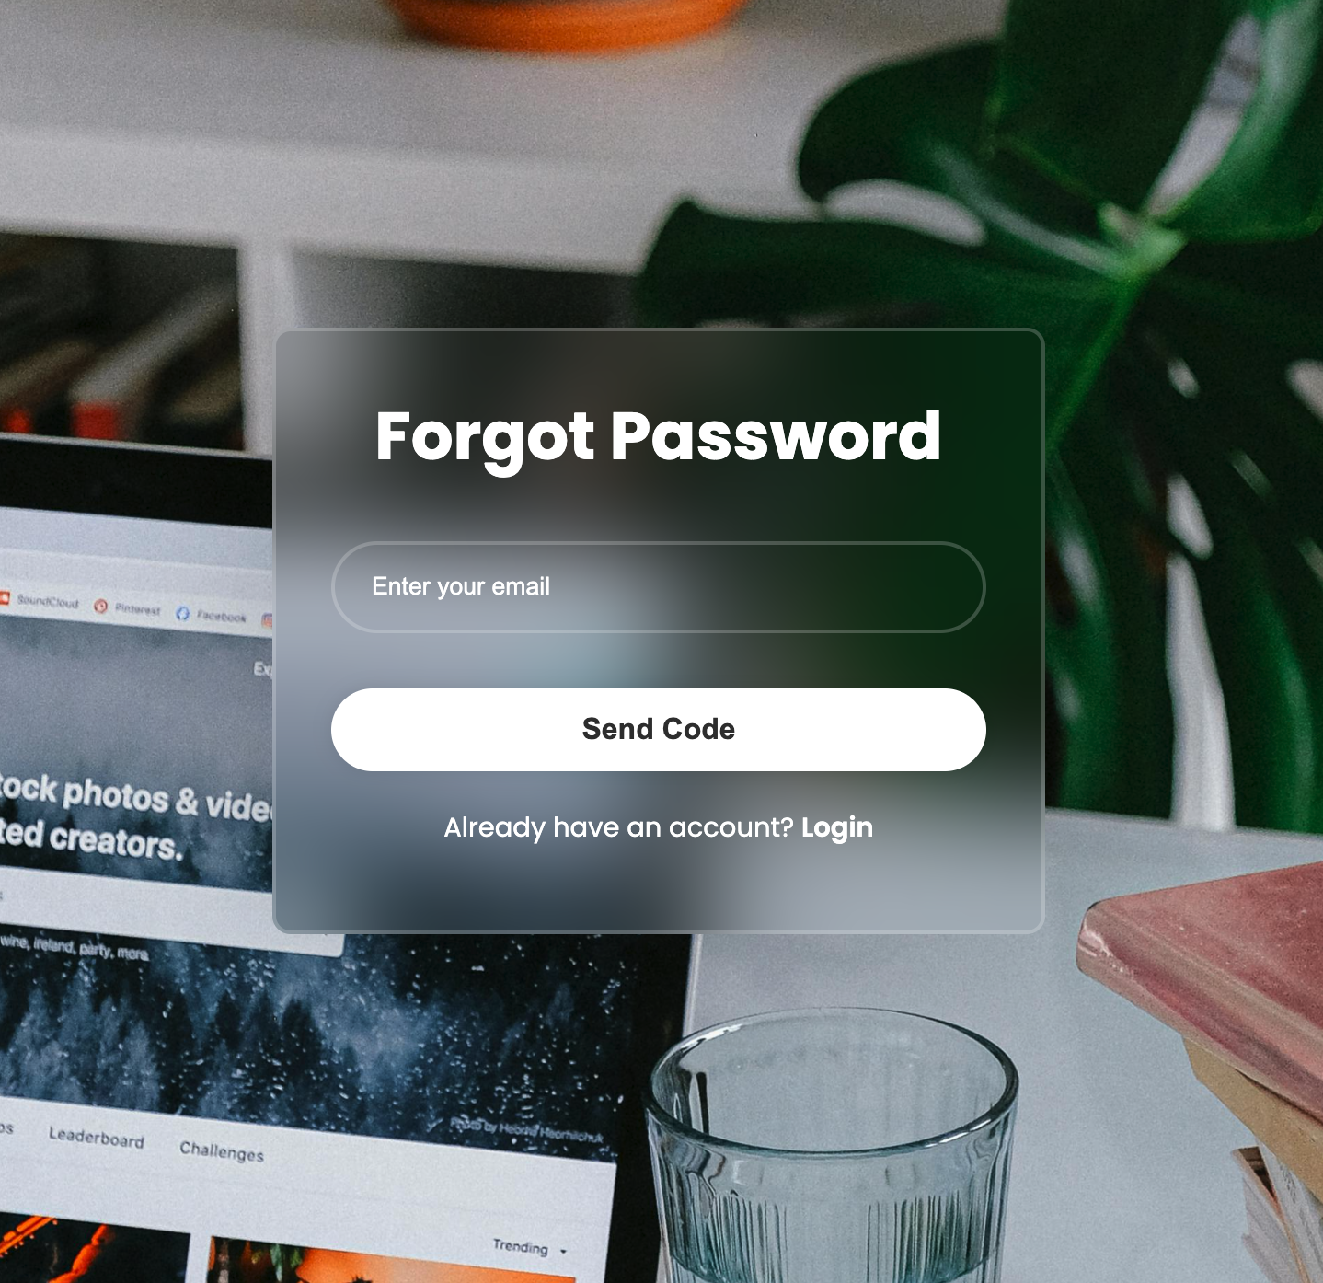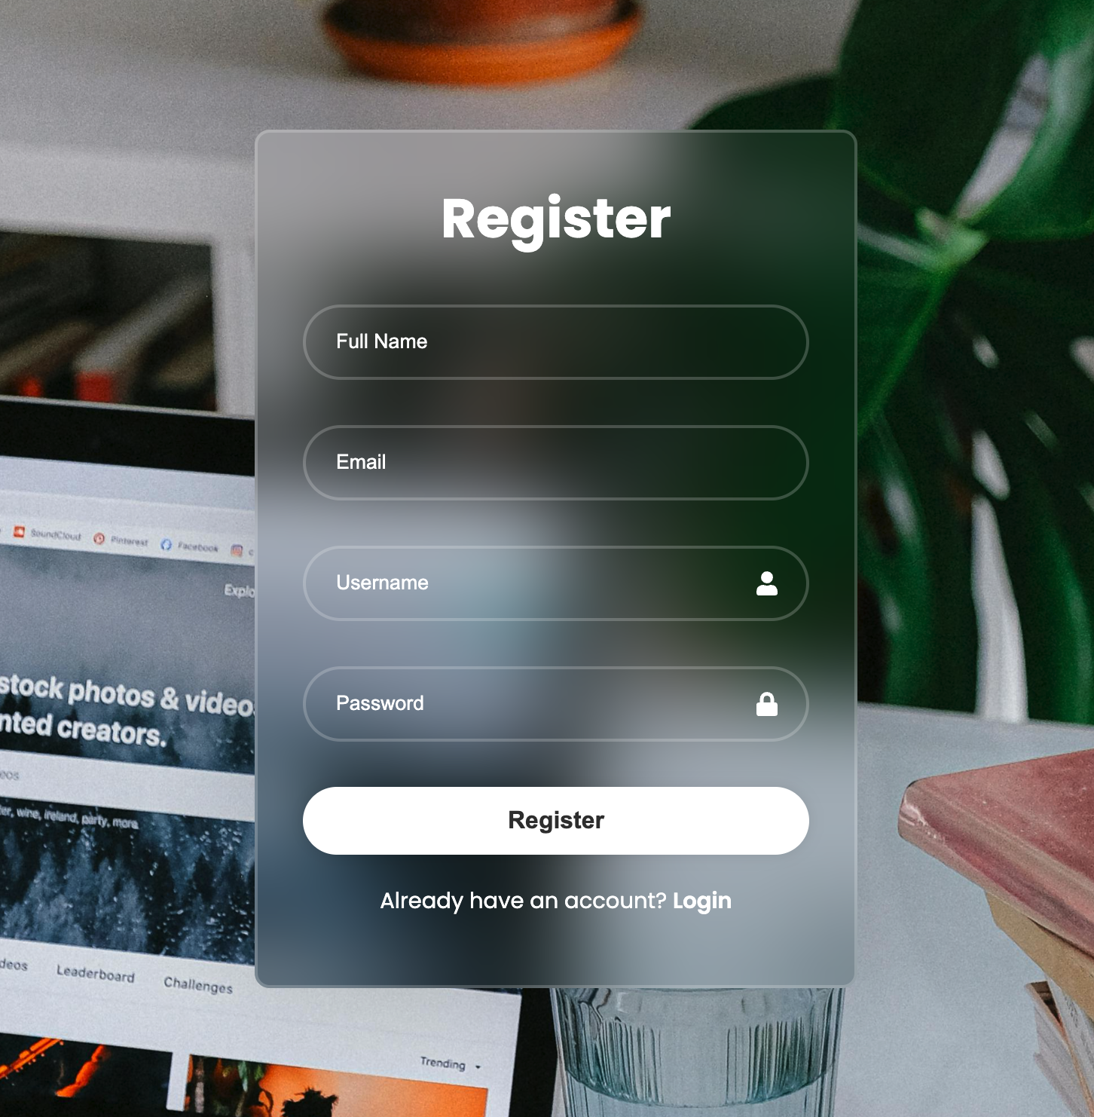

Login Section:

We created a beautiful UI with a blur at the login box with handling user submit.

Let’s act like a new user. user goes to the register page, Entering some data like (email - username - full name - password). And send it to the backend.

When the user clicks “Register”, the frontend sends to the backend the data inserted and checks the email if it is inserted before or invalid email. If it met the conditions, it is sent to the MongoDB and stored in its dataset, Ready to be accessed at any time. Also, we encoded the password to increase security on the website.



We also used Flask to process user requests and return responses in JSON format, making our website interactive with the user. And it is simple to use.



When a user submits, we take the data inserted by the user and send it to the backend (data like username and password).

The inserted data we encode the password and match it with the already encoded password in MongoDB. If it matches the user logged in, if it doesn’t match, we show a pop up (“Invalid Username or Password”).

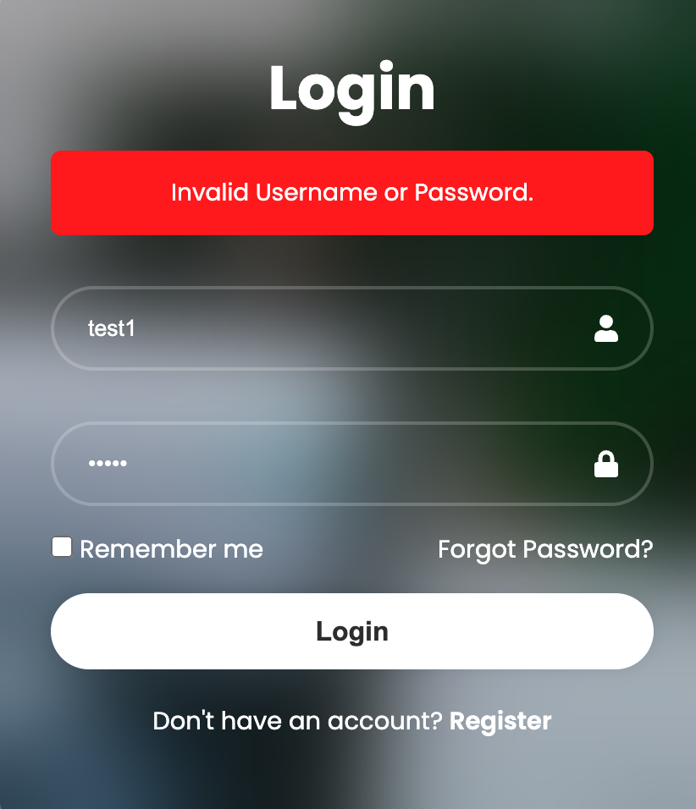

Also, we made a Remember me checkbox. If you check it, it creates a “logged in” True Boolean in local storage. So, the second time you open the website it checks for this variable if it is created or not. And forward you to the tasks page (Default Page).

Not every user remembers or writes his password down in a note or a paper, so many users forget their account’s password.

But users can’t create a second account with the same email so how do we solve that? As developers, we created a forget password page, enter your email and you will get an email in your inbox saying verification code. copy and paste it in the input box and you can make a new password for your account, making it easy to access it again, but Don't Forget it Again!

**Tasks Section:**

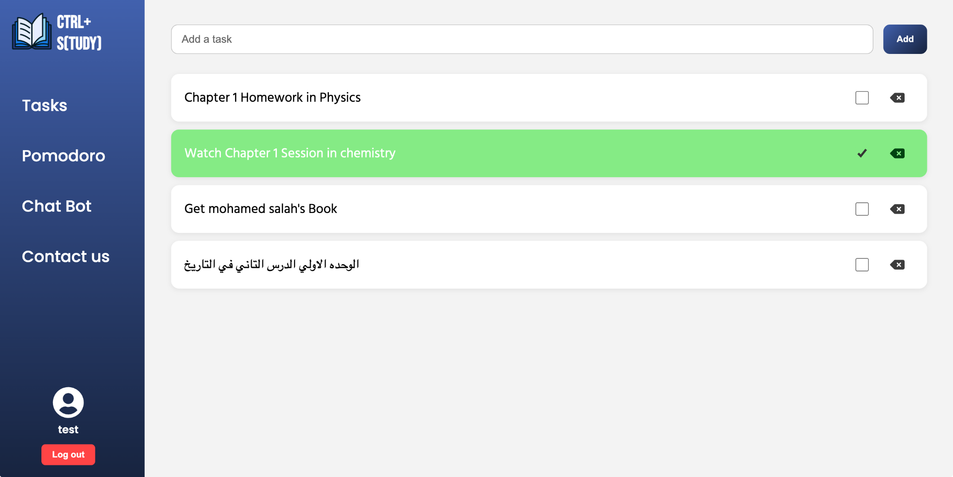

Once you log in, you are redirected to the **Tasks Page**, which serves as the main hub for managing your daily activities. This page currently provides **three essential features**:

* **Add Task**: allows the user to create and store new tasks efficiently.
* **Delete Task:** gives the user full control to remove tasks that aren’t needed.
* **Check Task**: enables the user to mark completed tasks, helping track progress easily.

These three features form the **foundation of any basic task management system**

**Pomodoro Section**

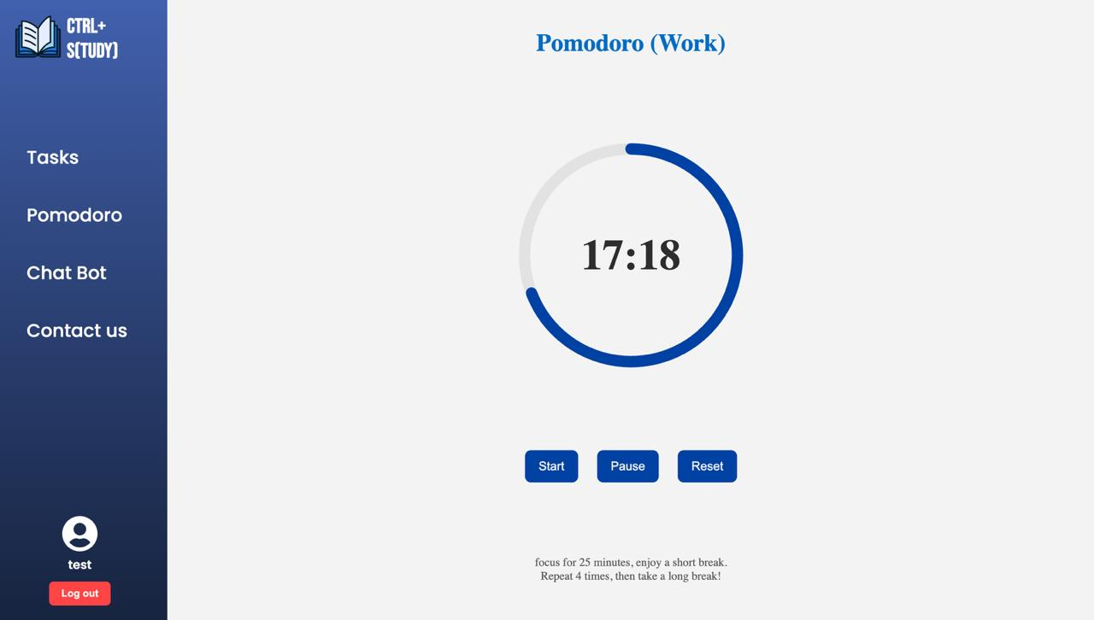

A Pomodoro webpage is basically an online timer that uses the Pomodoro Technique, a time management method where you work in focused chunks usually 25 minutes followed by a short break of 5 minutes. After a few rounds, you take a longer break. It has multiple importances such as:

1. It helps you stay focused instead of getting distracted or procrastinating.
2. It avoids burnouts so those small breaks keep your brain fresh, so you don’t get too drained.
3. It also builds discipline over time; your brain gets used to focusing better

Here is why it helps us so because that our brains aren’t built to concentrate non-stop for hours. A Pomodoro webpage keeps track of the time for you, so you don’t have to stress about checking the clock. It just tells you when to work and when to rest. It’s like having a little productivity buddy with you everywhere you go

This encourages students to stay productive by switching between work and break sessions and even show a pop-up window when you end the phase.

Behind the scenes, we used pure math and JavaScript to simulate a timer that counts down in real time and store where he left and returns to not lose progress.

We also added some visuals to make the website more modern like the circle around the timer in blue color (main website color) that moves in anticlockwise movement.

**Chatbot Section**

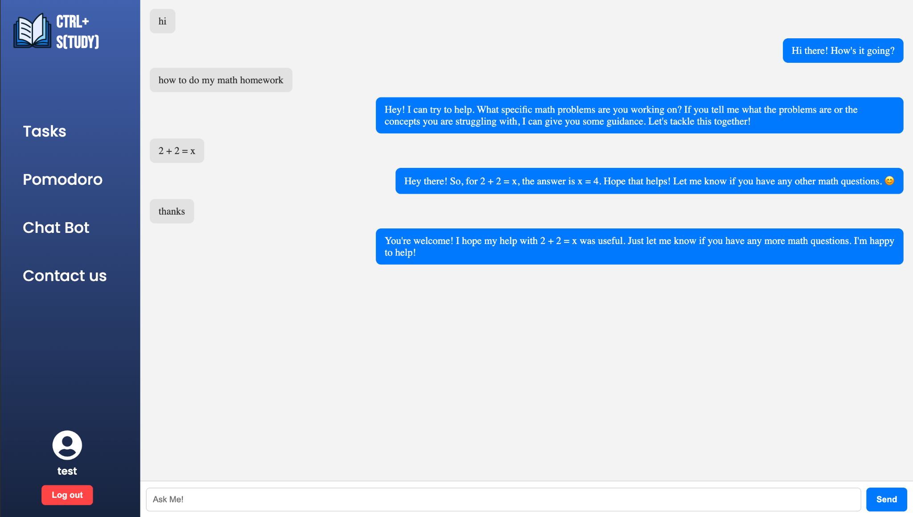

We made a chatbot assistant called bor3i. Bor3i's main goal is to help students by answering their questions.

Bor3i’s responses come from Gemini, a powerful AI who proved himself against other AI modules.

We also included chatbot messages in the response we send to the Api, so it gives logical answers.

If Bor3i struggles with a question, he doesn’t make up an answer. He simply says “I can't do that “. This makes him honest and helpful.

**Technical Details About our Chatbot:**

* **Frontend:** We used React with CSS to build interactive Ai chat to provide a user-friendly experience
* **Backend:** We use Flash to handle Api calls and responses efficiently.
* **Response Login:** 
  + The user’s Message sent by using Api.
  + The backend sends the message to Gemini with a prompt designed to meet our needs.
  + Gemini sends back responses, and we added it to messages and chat frontend.

**Why we Created Bor3i?**

Bor3i isn’t just a chatbot assistant, he is a study companion, he helps users get fast responses, saving his time going to other webpages looking for answers.

Ai proved itself in the last couple of years, making this website Education + Ai, shows how we try to keep up with the latest technologies.

**Contact us**

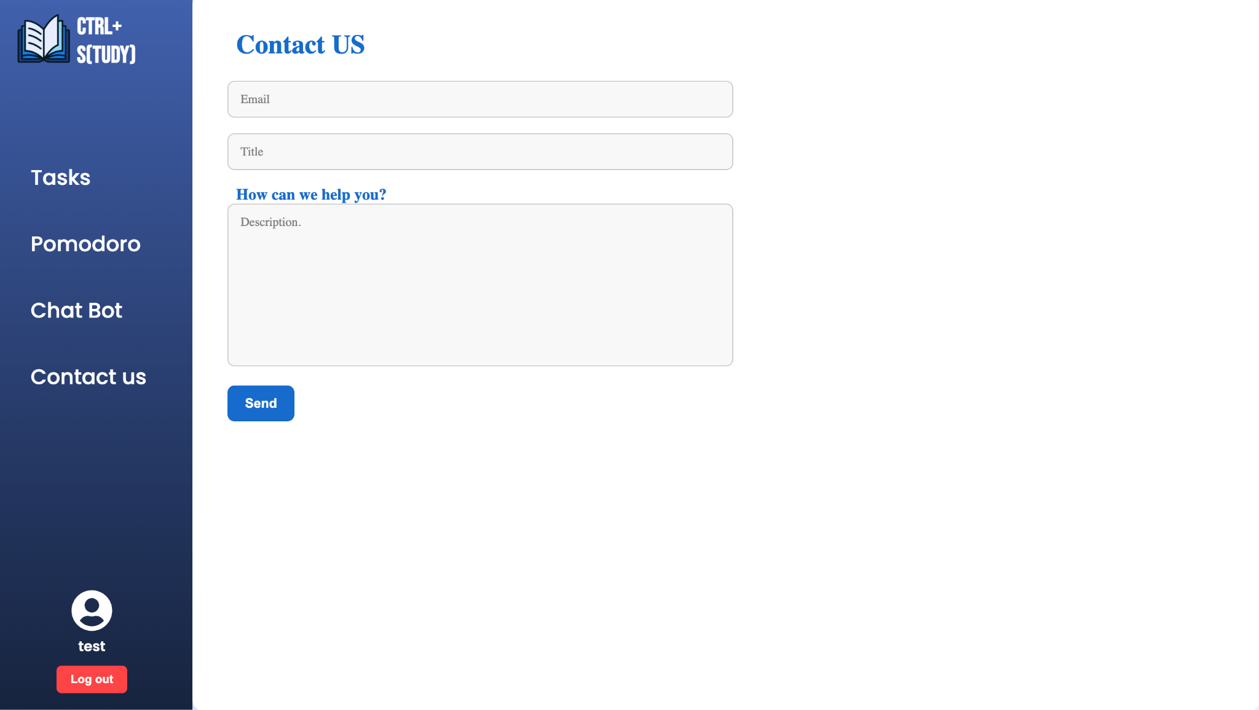

Do you have a problem? Don't be shy to Contact us!

This is the idea of this webpage; it handles users’ submission and sends it to our company email in this format.

We may be as developers didn’t see an error, that page helps us to take responses as fast as possible after contacting us and improve user’s experience.

we used a library called SMTP, you can send emails by giving sender email, target email, Content. It is very easy to use and learn. That’s why we chose it.

***The End***

We thank Protons Community for helping us achieve this and gain this useful experience, making us true developers and programmers. We will miss the journey we had together.

